Creating Holiday Cards for Seniors At Starbucks

On December 13th, 2025, Lucy Zhang, Megan Wang, and Anna Hou gathered at a local Starbucks in Edina, bringing art supplies to create handmade cards for seniors during winter break. Together, they made a total of 37 cards, which were delivered to the organization Gifts for Seniors before the holidays, spreading warm wishes and holiday cheer to older adults in the community.
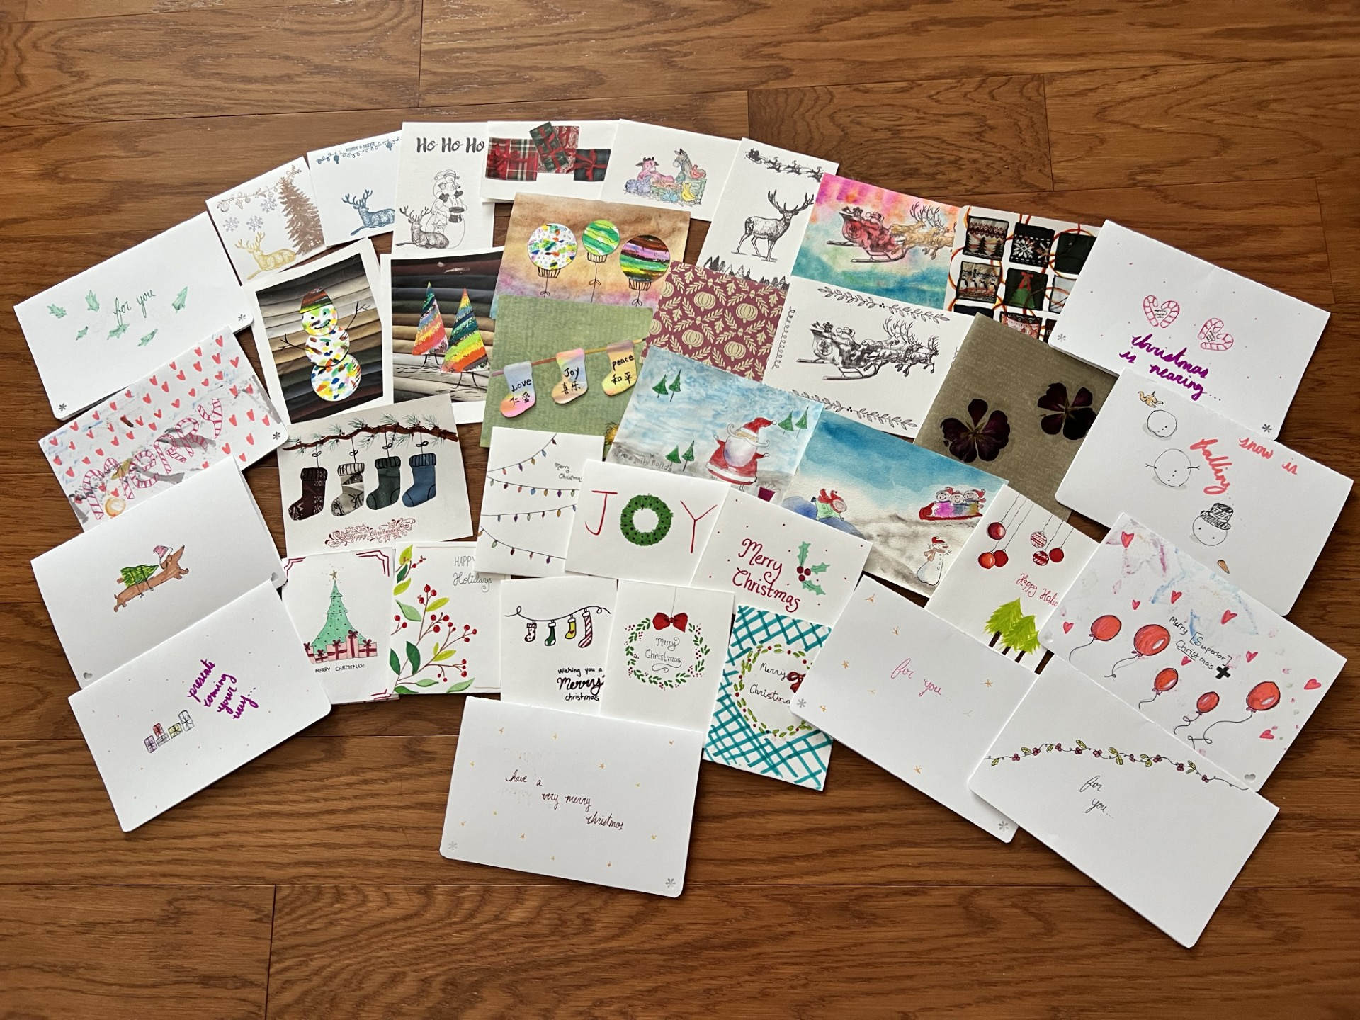
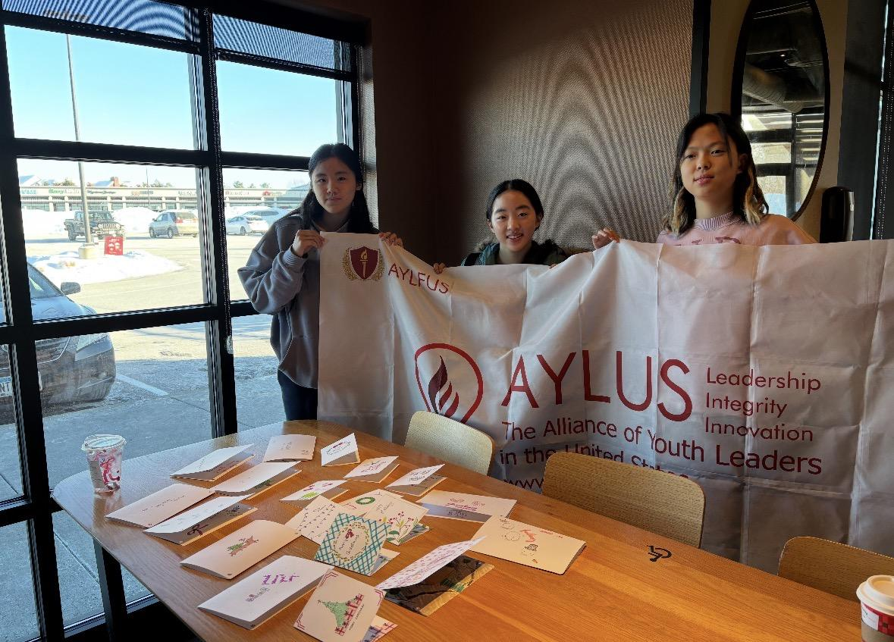
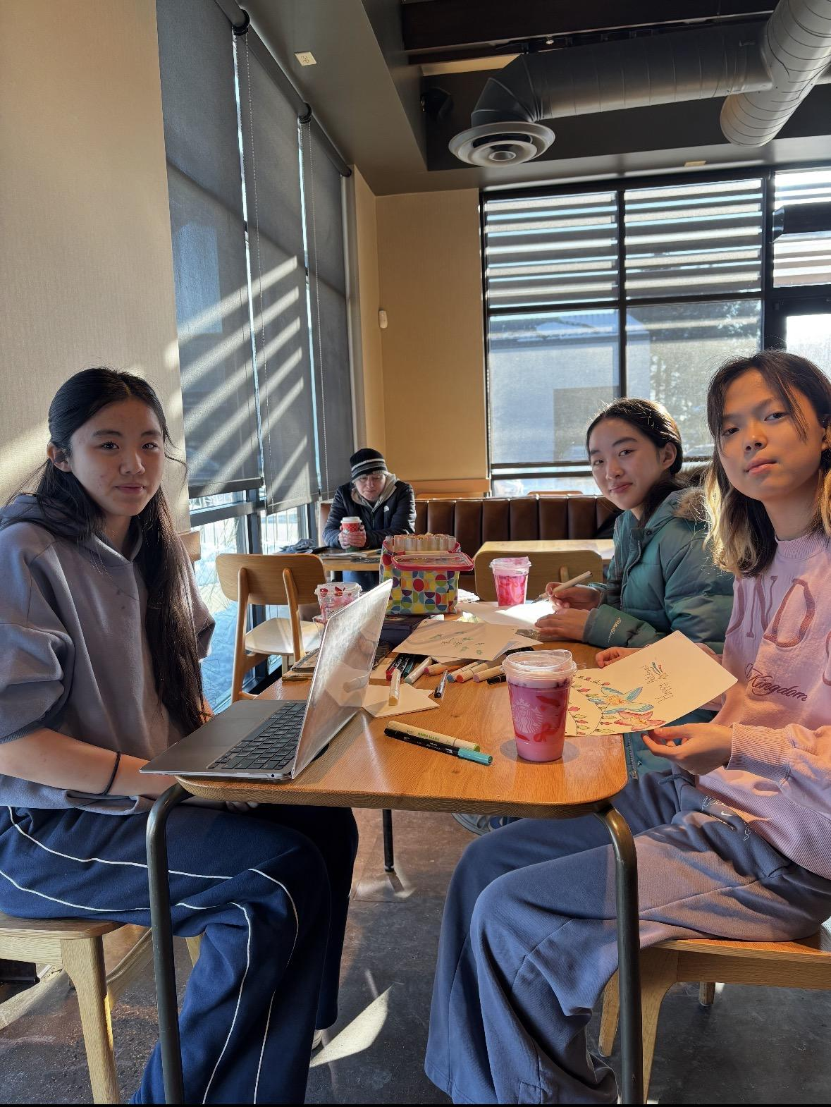
All participants (Lucy Zhang, Megan Wang, and Anna Hou) earned 2 hours of volunteer service during this activity.

