VOLUNTEER OPPORTUNITIES

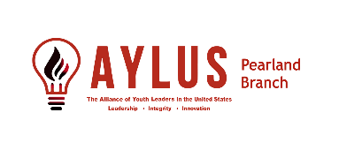

**May**

**5-10 GiGi’s Playhouse Houston GFAC Event at Episcopal HS**

**5-11 Mother’s Day Walk Performance**

**5-17 Volunteer Fair – West Pearland Library**

**5-17 LSA Health Fair**

**5-22 End of Summer Community Party – Tom Bass Regional Park**

**5-24 Pearland My PlayClub (#25)**

**June**

**6-3,4,6 2025 LSA SMILE Camp WK#1**

**6-5 Bucket Drumming for All at GiGi’s Sugarland**

**6-7 My PlayClub #25**

**6-10,11,13 2025 LSA SMILE Camp WK#2**

**6-12 Bucket Drumming for All at GiGi’s Sugarland**

**6-17,18,20 2025 LSA SMILE Camp WK#3**

**6-19 Bucket Drumming for All at GiGi’s Sugarland**

**6-24,25,27 2025 LSA SMILE Camp WK#4**

**6-26 Bucket Drumming for All at GiGi’s Sugarland**