VOLUNTEER OPPORTUNITIES

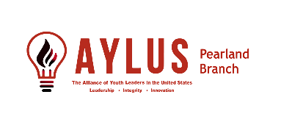

**June**

**6-11,13 2025 LSA SMILE Camp WK#2**

**6-12 Bucket Drumming for All at GiGi’s Playhouse Sugarland**

**6-17,18,20 2025 LSA SMILE Camp WK#3**

**6-19 Bucket Drumming for All at GiGi’s Playhouse Sugarland**

**6-24,25,27 2025 LSA SMILE Camp WK#4**

**6-26 Bucket Drumming for All at GiGi’s Playhouse Sugarland**

**6-27 West Pearland Library Book Sale Preparation**

**6-28 West Pearland Library Book Sale**

**6-28 CARE**

**6-29 Freedom Festival**

**July**

**7-4 Pearland Independece Day Celebrationn**

**7-8,9,11 2025 LSA SMILE Camp WK#5**

**7-15,16,18 2025 LSA SMILE Camp WK#6**

**7-22,23,25 2025 LSA SMILE Camp WK#7**

**7-29,30 2025 LSA SMILE Camp WK#8**