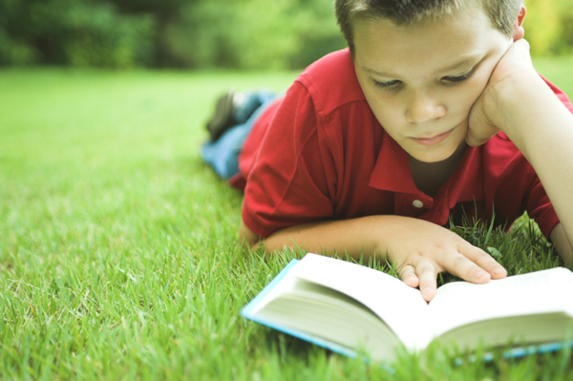  donate now  AYLUS 2017 book drive  Give the Gift of Reading  This year you can help by visiting Goodwill’s website, http://www.goodwill.org and donating there, local libraries, hospitals, and other facilities: Please contact them first to find out which books they will accept.   | Who: All students K-12  ────  What: Book Drive  ────  When: Now-August 31, 2017  ────  Where: Libraries, Hospitals, Charities  ────  How: Through collecting books and donating them  Coordinators:  Emily Wang  Kevin Chen  --------------------  Contact  Emi77479@gmail.com  713-885-3896

