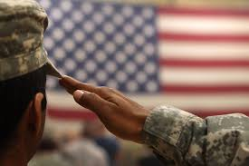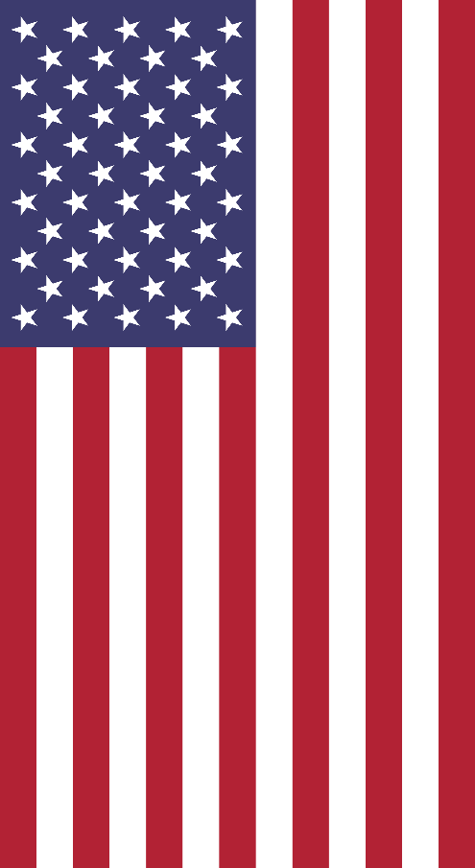

AYLUS Veteran’s

Appreciation Day

November 11th marks the annual date of America’s celebration and recognition of the sacrifices of our veterans. In addition, November 11th represents the end of World War 1 between the Allied nations and Germany. In order to thank those for their services and commitment to preserving safety and peace for our country and for the world, AYLUS will be hosting the national Veteran’s Appreciation Event.

AYLUS branches are encouraged to participate in the event by sending care packages to troops in foreign countries, inviting veterans to give speeches at schools, or simply to just delivering cards and performing services at veterans’ facilities. Event ideas are not limited to those listed above, and any branch that has a creative idea is urged to share with us.

Often, veterans do not get nearly as much credit for their services as they deserve. They have dedicated their lives for the safety of ours and have even paid the ultimate sacrifice, and yet in return we tend to forget their good deeds. Although our Veteran’s Day event has a fixed start and end date, we should continue to extend our support and love to our friends and always bear in mind that our safety is always accounted for by the veterans.

Event Details

Who: All branches are encouraged

What: Find ways to celebrate Veteran’s Day and raise awareness

When: Nov 1-20

How: Decide activities within your own branches

Coordinators: Kevin Chen, Spencer Liu

Contact: kevinxiaobao@gmail.com, spencerliu7@gmail.com

